DEEP LEARNING PRACTICAL 8

**Aim :-**

Learn about real time object detection.

Observations :-

Darknet prints out the objects it detected, its confidence and how long it took to find them.

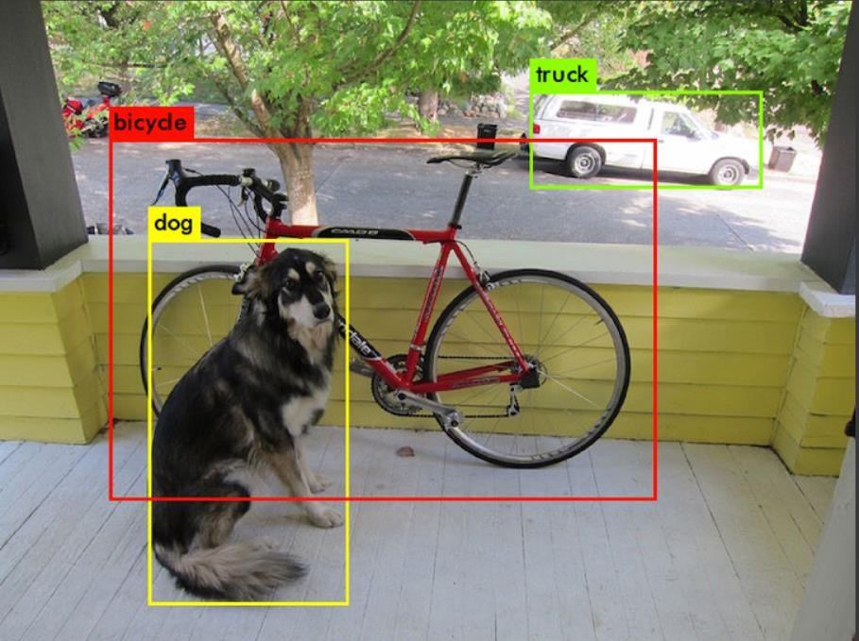

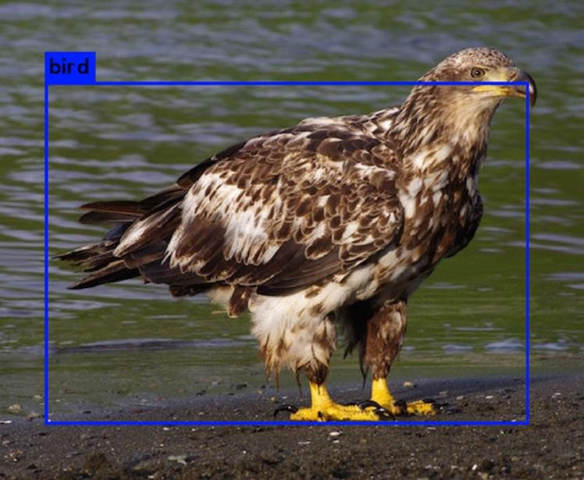

The link of the colab sheet is given below :-

[https://colab.research.google.com/drive/1fEwnYQYEvlF1hsNZVDetH1N52CWX-](https://colab.research.google.com/drive/1fEwnYQYEvlF1hsNZVDetH1N52CWX-G2y#forceEdit%3Dtrue%26sandboxMode%3Dtrue%26scrollTo%3DwLFL4YtJIIo3) [G2y#forceEdit=true&sandboxMode=true&scrollTo=wLFL4YtJIIo3](https://colab.research.google.com/drive/1fEwnYQYEvlF1hsNZVDetH1N52CWX-G2y#forceEdit%3Dtrue%26sandboxMode%3Dtrue%26scrollTo%3DwLFL4YtJIIo3)

Conclusion :-

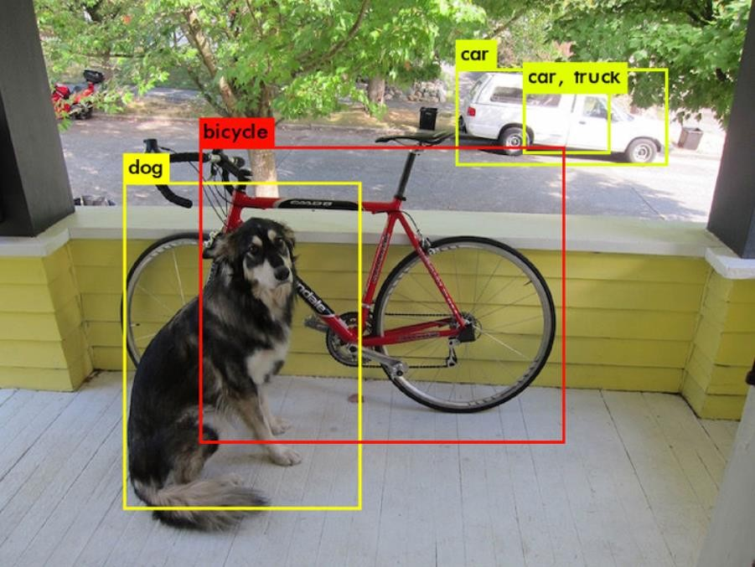

The predicted image by the model is as given above.

It can successfully predict the objects such as bicycle, truck, dog, etc.